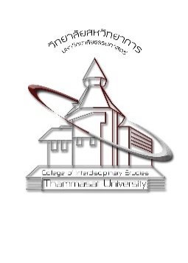 | APPLICATION FORM FOR  SHORT-TERM SCHOLAR  EXCHANGE PROGRAM | Please affix  your photo  here.
Host Institution: College of Social Sciences, National Chengchi University (NCCU), Taipei, ROC Taiwan
- Name and Last Name in English as appeared on your passport
………………………………………………………………………….
- Academic Rank ……………………………………………………………………………………………..
- Highest Degree obtained, Name of the Institution, and Year of Degree Conferral
…………………………………………………………………………………………………………………………………………………………………………………………………………………………………
- Please indicate your expertise in 3-4 keywords
……………………………………………………………………………………………………………………………………………………………………………………………………………………………………
- Lecture topic(s) and academic activities to be done during your stay at NCCU
………………………………………………………………………………………………………………………………………………………………………………………………………………………………………………………………………………………………………………………………………………………
- Your proposed date of stay at NCCU in 2018.
(Please be noted that the first semester of NCCU is usually from mid-September to mid-January. Your stay must begin before 31 December 2018 and last for 10 to 14 days.)
…………………………………………………………………………………………………………………
- Your email and other contact channels (if any) …………………………………………………………

Please attach your English CV and sign your name below

………………………………
( )
….(date/month/year)……

